**The future of AI : how artificial intelligence will change the world**

AI is expected to improve industries like healthcare, manufacturing and customer service, leading to higher-quality experiences for both workers and customers. However, it does face challenges like increased regulation, data privacy concerns and worries over job losses.

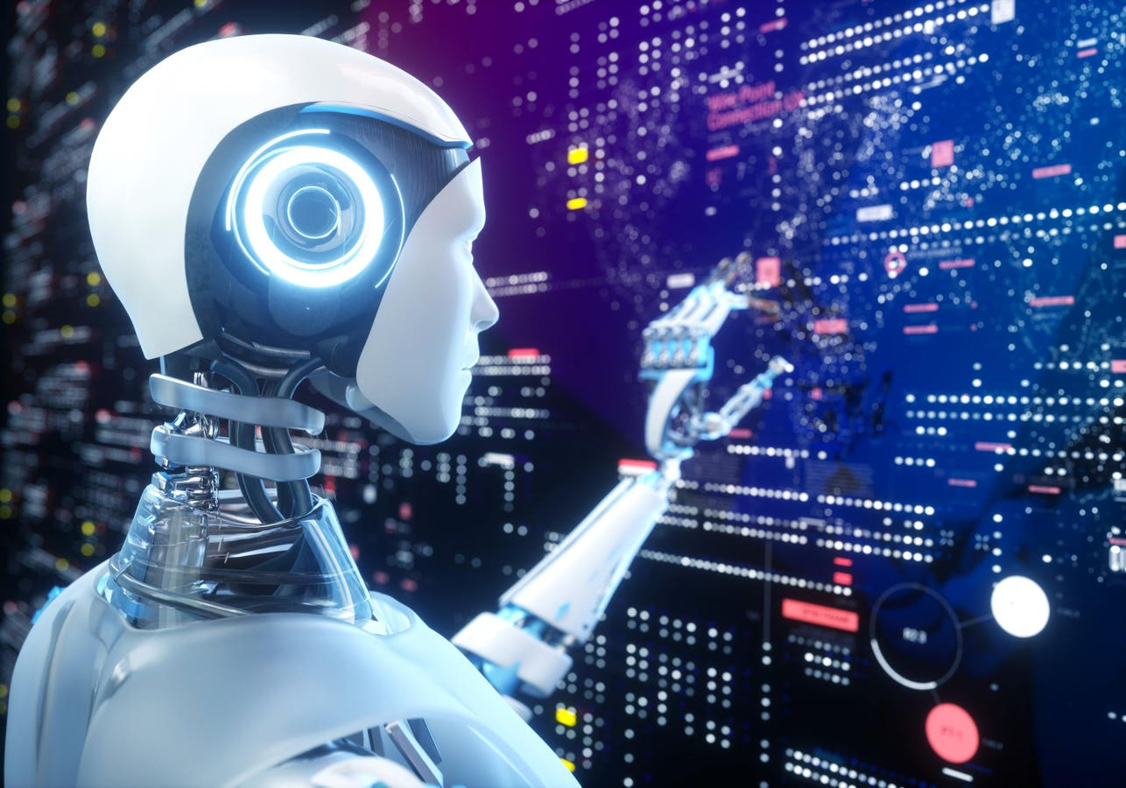**Innovations in the field of**[**artificial intelligence**](https://builtin.com/artificial-intelligence)**continue to shape the future of humanity across nearly every industry. AI is already the main driver of emerging technologies like big data, robotics and IoT, and**[**generative AI**](https://builtin.com/artificial-intelligence/generative-ai)**has further expanded the possibilities and popularity of AI.**

**According to a**[**2023 IBM survey**](https://www.multivu.com/players/English/9240059-ibm-2023-global-ai-adoption-index-report/)**, 42 percent of enterprise-scale businesses integrated AI into their operations, and 40 percent are considering AI for their organizations. In addition, 38 percent of organizations have implemented generative AI into their workflows while 42 percent are considering doing so.**

**With so many changes coming at such a rapid pace, here’s what shifts in AI could mean for various industries and society at large**.

**The Evolution of AI**

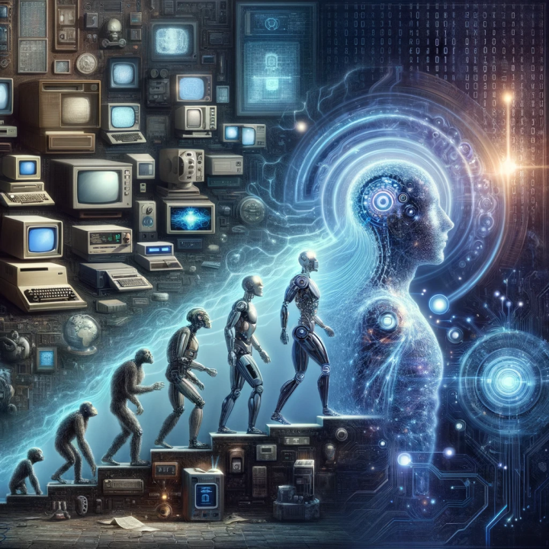AI has come a long way since 1951, when the [first documented success of an AI computer program](https://www.britannica.com/technology/artificial-intelligence/Alan-Turing-and-the-beginning-of-AI) was written by Christopher Strachey, whose checkers program completed a whole game on the Ferranti Mark I computer at the University of Manchester. Thanks to developments in machine learning and [deep learning](https://builtin.com/machine-learning/what-is-deep-learning), [IBM’s Deep Blue](https://www.history.com/this-day-in-history/deep-blue-defeats-garry-kasparov-in-chess-match) defeated chess grandmaster Garry Kasparov in 1997, and the company’s [IBM Watson](https://www.ibm.com/history/watson-jeopardy) won Jeopardy! in 2011.

Since then, generative AI has spearheaded the latest chapter in AI’s evolution, with OpenAI releasing its [first GPT models](https://openai.com/research/language-unsupervised) in 2018. This has culminated in OpenAI developing its [GPT-4](https://builtin.com/articles/gpt4) model and [ChatGPT](https://builtin.com/artificial-intelligence/what-is-chatgpt" \t "_blank), leading to a proliferation of AI generators that can process queries to produce relevant text, audio, [images](https://builtin.com/artificial-intelligence/ai-art-generators) and other types of content.

**How AI Will Impact the Future**

## Job Disruption

[Business automation](https://builtin.com/artificial-intelligence/automation-best-practices) has naturally led to fears over [job losses](https://builtin.com/artificial-intelligence/ai-replacing-jobs-creating-jobs). In fact, employees believe almost [one-third of their tasks](https://asana.com/work-innovation-lab/wp-content/uploads/2023/08/The-State-of-AI-at-Work.pdf) could be performed by AI. Although AI has made gains in the workplace, it’s had an unequal secretaries 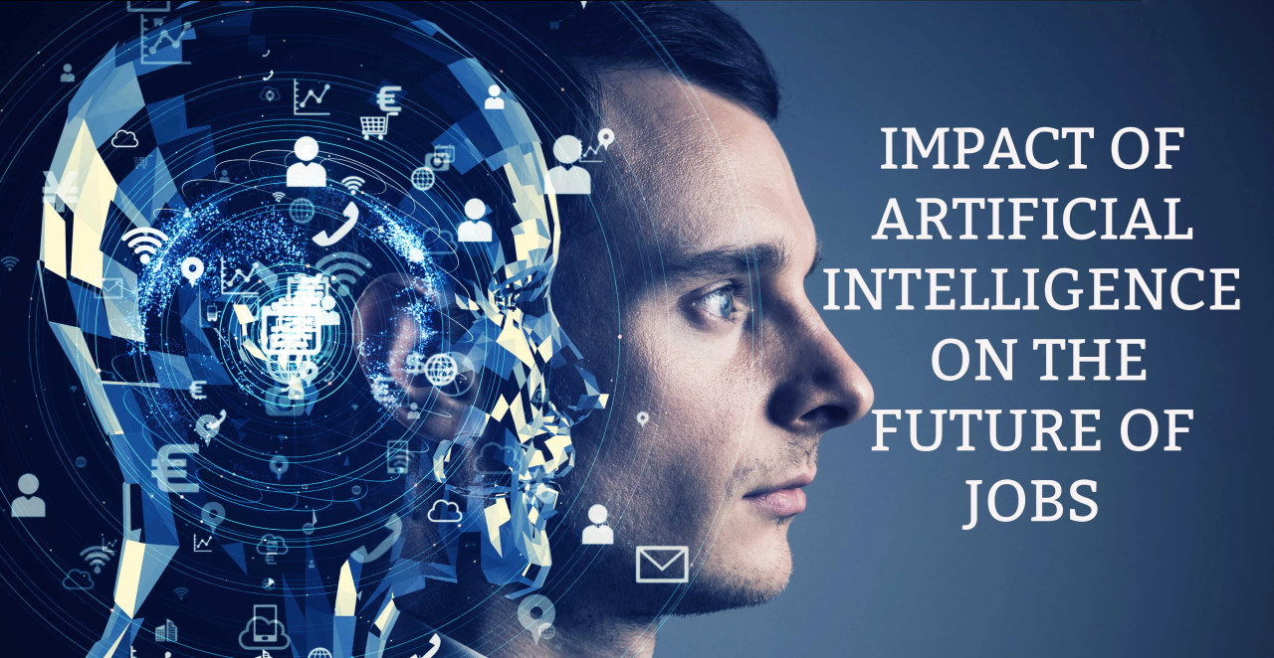are at risk of being automated, but the [demand for other jobs](https://www.weforum.org/agenda/2023/05/jobs-lost-created-ai-gpt/) like machine learning specialists and information security analysts has risen.

Workers in more skilled or creative positions are more likely to have their [jobs augmented by AI](https://builtin.com/artificial-intelligence/artificial-intelligence-revolution-workers), rather than be replaced. Whether forcing employees to learn new tools or taking over their roles, AI is set to spur [upskilling](https://builtin.com/employee-engagement/upskilling" \t "_blank) efforts at both the individual and [company level](https://builtin.com/career-development/upskilling-staff-retention).

“One of the absolute prerequisites for AI to be successful in many [areas] is that we invest tremendously in education to retrain people for new jobs,” said Klara Nahrstedt, a computer science professor at the University of Illinois at Urbana–Champaign and director of the school’s Coordinated Science Laboratory.

## Climate Change Concerns

On a far grander scale, AI is poised to have a major effect on sustainability, climate change and environmental issues. Optimists can view AI as a way to make [supply chains](https://builtin.com/logistics/artificial-intelligence-supply-chain) more efficient, carrying out predictive maintenance and other procedures to [reduce carbon emissions](https://builtin.com/artificial-intelligence/ai-increase-fleet-efficiency).

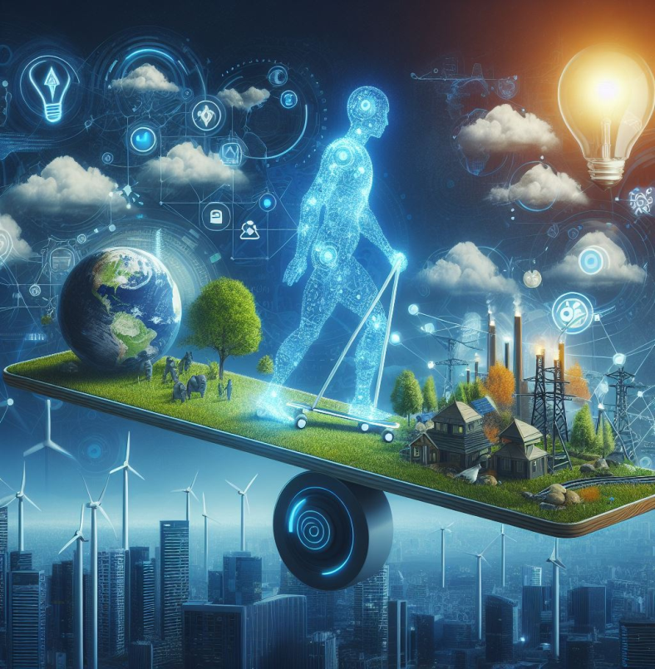At the same time, AI could be seen as a key [culprit in climate change](https://builtin.com/artificial-intelligence/ai-climate-change-dilemma). The energy and resources required to create and maintain AI models could [raise carbon emissions](https://www.theguardian.com/technology/2024/mar/07/ai-climate-change-energy-disinformation-report#:~:text=The%20burgeoning%20electricity%20demands%20of%20AI%20means%20that%20a%20doubling%20of%20data%20centers%20to%20help%20keep%20pace%20with%20the%20industry%20will%20cause%20an%2080%25%20increase%20in%20planet%2Dheating%20emissions%2C%20even%20if%20th) by as much as 80 percent, dealing a devastating blow to any sustainability efforts within tech. Even if AI is applied to [climate-conscious technology](https://builtin.com/greentech/sustainable-abundance), the costs of building and training models could leave society in a worse environmental situation than before.

## What Industries Will AI Impact the Most?

There’s virtually no major industry that modern AI hasn’t already affected. Here are a few of the industries undergoing the greatest changes as a result of AI.

### AI in Manufacturing

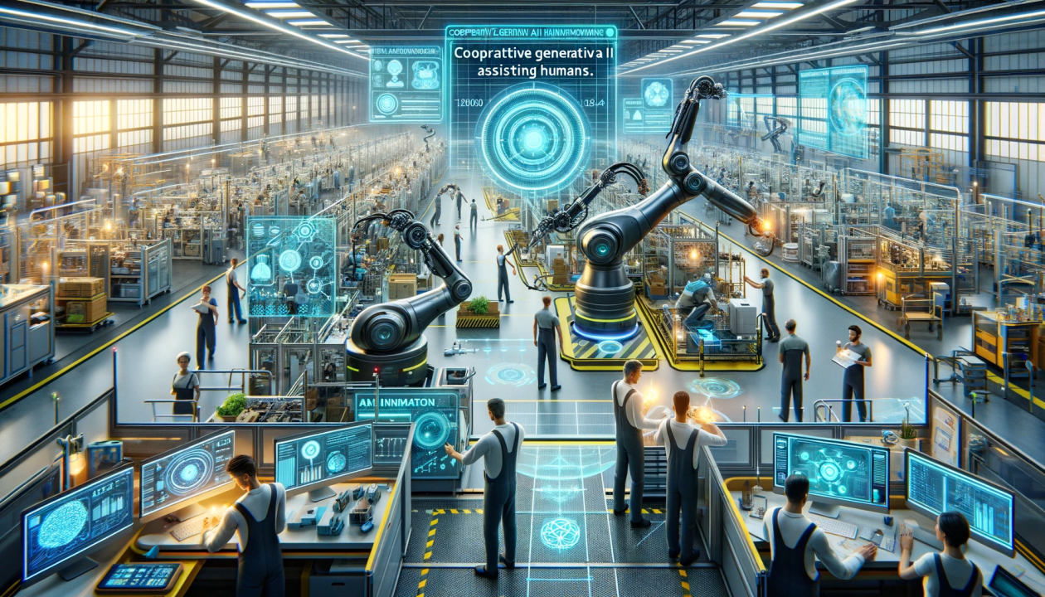Manufacturing has been benefiting from AI for years. With AI-enabled robotic arms and other manufacturing bots dating back to the 1960s and 1970s, the industry has adapted well to the powers of AI. These [industrial robots](https://builtin.com/robotics/industrial-robot) typically work alongside humans to perform a limited range of tasks like assembly and stacking, and predictive analysis sensors keep equipment running smoothly.

### AI in Healthcare

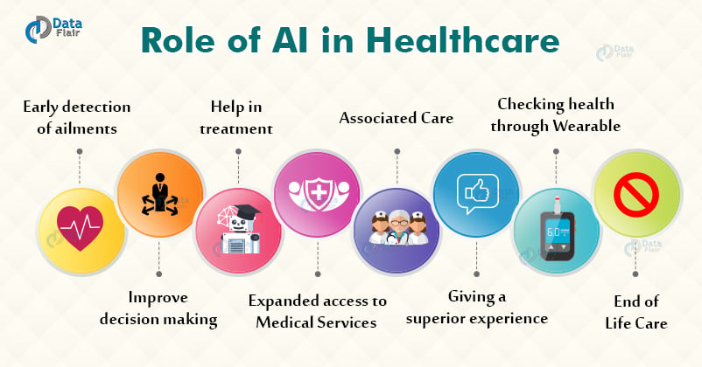

It may seem unlikely, but [AI healthcare](https://builtin.com/artificial-intelligence/artificial-intelligence-healthcare) is already changing the way humans interact with medical providers. Thanks to its [big data](https://builtin.com/big-data) analysis capabilities, AI helps identify diseases more quickly and accurately, speed up and streamline drug discovery and even monitor patients through virtual nursing assistants.